Git revert

* The revert command helps you undo an existing commit.
* It does not delete any data in this process instead rather git creates a new commit with the included files reverted to their previous state so your version control history moves forward while the state of your files moves backward.

**Difference between reset and revert**

**Reset** -> we use reset command before commit

**Revert ->** we use revert command after commit

**git status**

**cat > newfile** {create one new file }

**hi, final code for app**

**git add**

**git commit –m “I am demo”**

**git log –oneline**

**git revert <commit –id >**

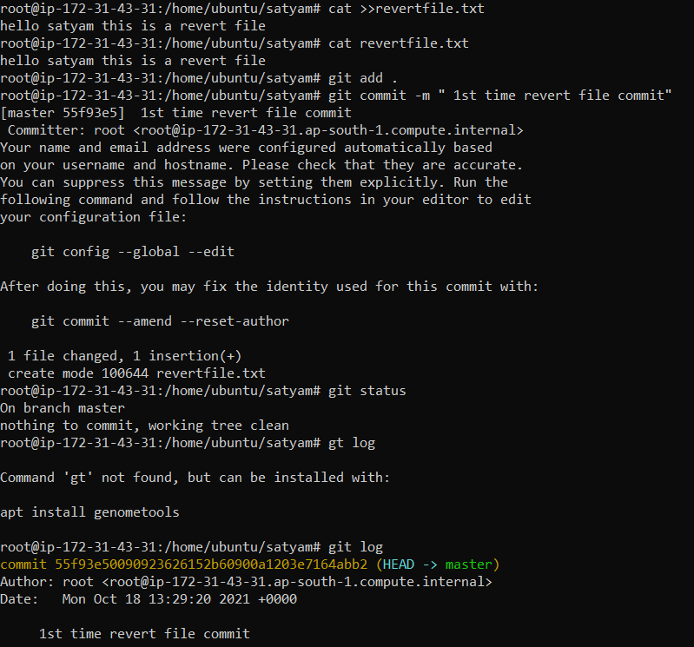

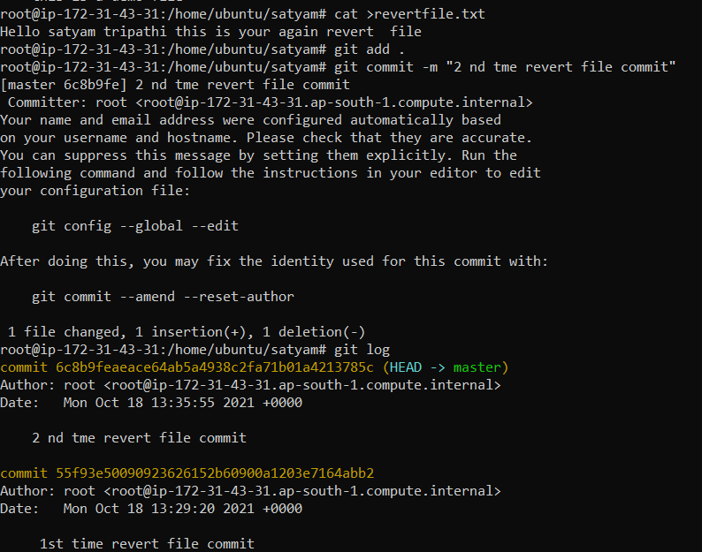



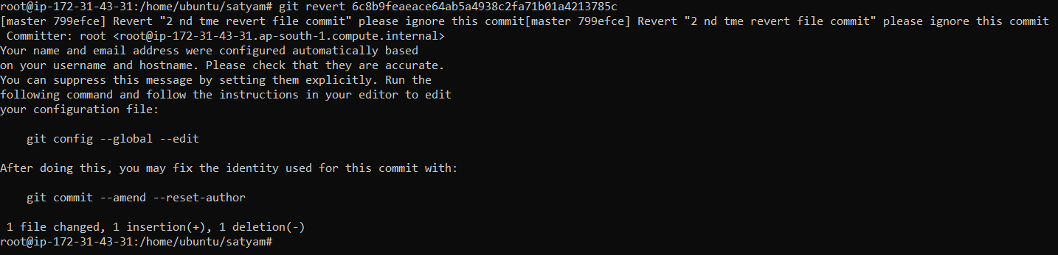

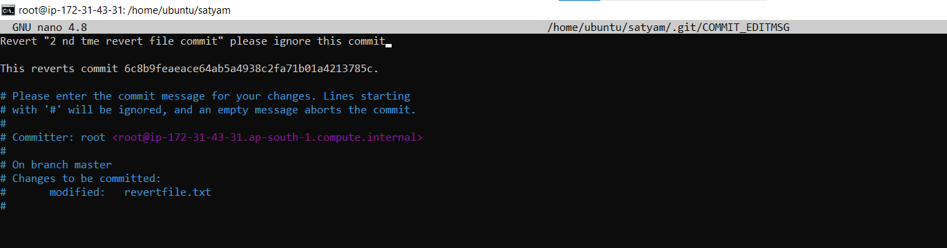



**How to remove untracked files**

git clean –n (they ask you before removing your files )

git clean –f ( delete files forcefully )

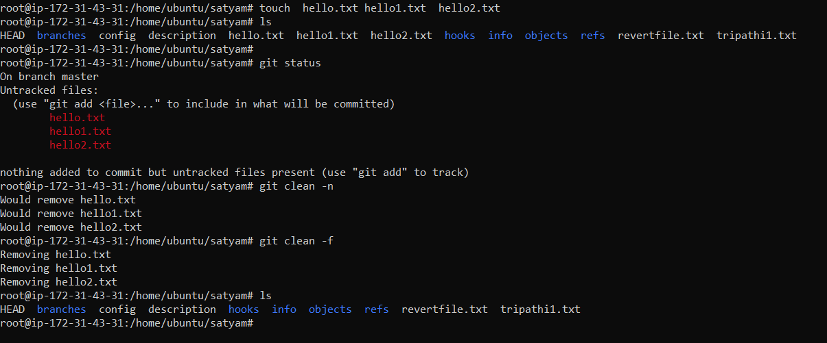

**GIT TAG**

* Tag operations allows giving meaningful to a specific version in a repository.
* If you want to apply tag in your commit you use tag command .

**To apply tag:-**

git tag –a <tagname> -m <message what you want><commit –ID>

**To see all the list of the tags :-**

git tag

**To see particular Commit Content by using tag :-**

git show <tagname>

**To delete a tag :-**

git tag –d <tagname>

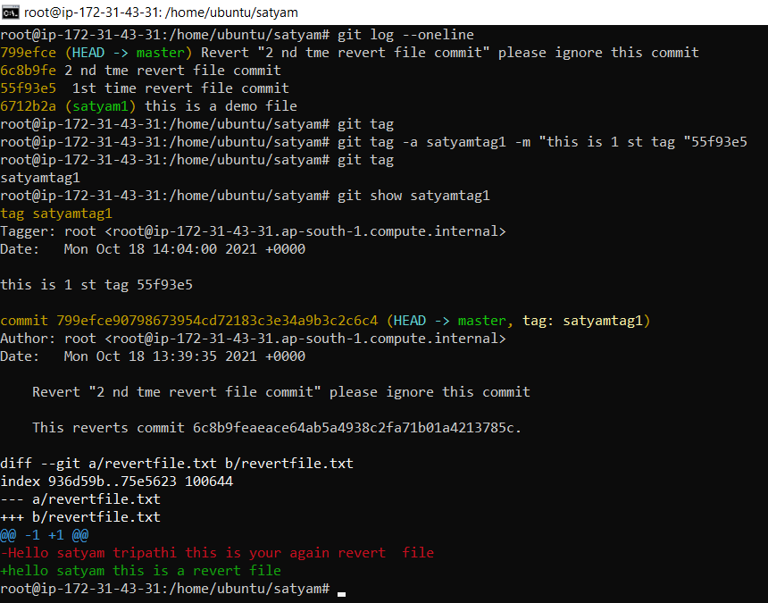

**Git Clone**

* Open github website
* Login and chose existing directory
* Now, go to your linux machine and run command
* git clone < url of git repository>
* it creates a loca repo automatically linux machine with the same name as in github account .